Current and Voltage
7th grade lesson plan
Sharon Tipton & Aileen Mattimore
NISMEC July 2010

Standards and Indicators:
Investigate and compare series and parallel circuits.

Objectives:
Students will be able to construct a series and a parallel circuit.
Students will be able to contrast the voltage and current in a series and parallel circuit.

Guiding Question(s):
Are the circuits that we construct for the electricity that we use series or parallel and why?

Pre-Planning:
The students will construct both a series and parallel circuit. They will then measure the current at various points in both the series and parallel circuit using a Current Probe. Students will also use a Voltage Probe to measure the voltage at different locations within the circuits.

We have assumed that in previous lessons the students have been introduced to the terms current, voltage, and circuit. It is also assumed that the students have utilized voltage and current probes in previous lessons, as well as created a single bulb circuit. The students should also be familiar with teacher expectations for notebook entries and need only a small reminder to include data and observations in their notebooks.

Lesson:
Engagement
Have the students share what they know about the vocabulary terms series and parallel. The teacher will create a list on the board of all the information shared by students and guide students to a working definition of these terms. Share with students that they will be exploring whether the circuits we use to deliver electrical energy are series or parallel in the following activities.

Investigation
See series and parallel circuits investigations details below.

Conclusion
Students will create white board presentations using the findings of their exploration to answer and support their answers to the following questions:

What are the differences between current and voltage in series and parallel circuits?
Are the circuits we use for electrical energy series or parallel and how do you know that?
What are the benefits of using a parallel circuit?

Materials:
Each group will need

1-White Board 2-White Board Markers 6-Wires
1-D Battery 1- Battery Holder 2-Light Bulb
2-Socket 1- Voltage Probe 1- Current Probe
1- Vernier LabQuest

Each student will need
1-Science Notebook
1-Pencil or Pen

Voltage and Current Investigation Details

Series Circuit:
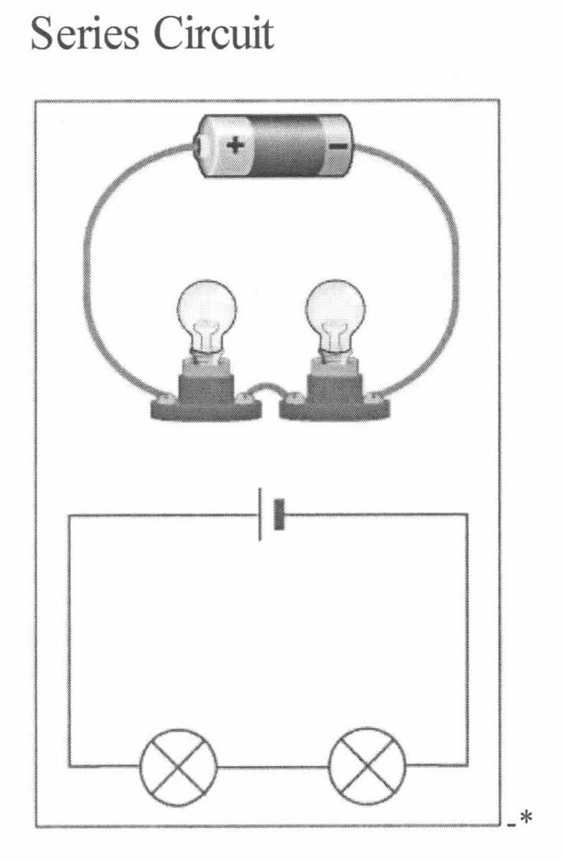
1. Create a series circuit.
2. What do you notice about the brightness of the bulbs?
3. Insert the Vernier current probe between the battery and Bulb 1.
4. Record the current reading, rounding the reading to the nearest hundredths place in your notebook.

****The (+) and (-) are symbols to indicate the direction of the current through the Labquest meter.

4. Now replace the wire between Bulb 1 and Bulb 2 with the current probe.
5. Next, replace the wire between Bulb 2 and the battery with the current probe.
6. What do you notice about the current readings when you compare them?

Checkpoint!
Meet with the teacher before continuing.
Remember that I will be checking your notebooks at each checkpoint for observations and data!

1. Reconnect the series circuit shown above. Measure the voltage across the battery by touching each end of the battery with one of the clips from the voltage probe. Record the voltage reading. Remember to round the reading to the nearest hundredths place.

2. Measure the voltage across the battery and Bulb 1 by touching the connection on the battery with one of the clips from the voltage probe and the connection on the socket for Bulb 1 with the other.

3. Now measure the voltage across Bulb 1 and Bulb 2 by touching the connection of the socket for Bulb 1 with one of the clips from the voltage probe and the connection on the socket for Bulb 2 with the other.

4. Next, you will measure the voltage across Bulb 2 and the battery by touching the connection on the battery with one of the clips from the voltage probe and the connection on the socket for Bulb 2 with the other.

5. Compare your voltage readings that you made for the connections between each socket and the battery and between the two sockets for the battery to the voltage across the battery. What can you conclude?

Checkpoint! Meet with teacher before continuing.

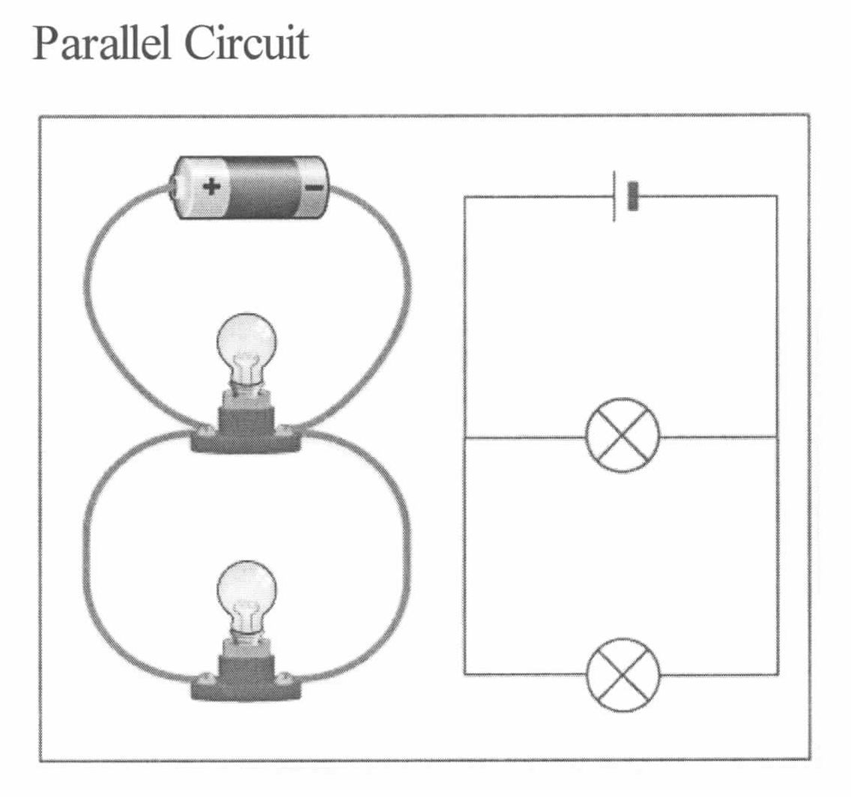
Parallel Circuit:

1.Create a parallel circuit.

2. What do you notice about the brightness of the bulbs?

3. Replace the wire between the battery and Bulb 1 with the current probe. Record the current readings, rounding the reading to the nearest hundredths place.

**** The (+) and (-) are symbols to indicate the direction of the current through the Labquest meter.

4. Now replace the wire between the battery and Bulb 2.

5. Next, replace the wire between both of the bulbs and the battery.

6. What do you notice about the current readings when you compare them?

Checkpoint! Meet with teacher before continuing.

1.Reconnect the parallel circuit shown above.

2. Measure the voltage across the battery and Bulb 1 by touching the connection on the battery with one of the clips of the voltage probe and the connection on the socket for Bulb 1 with the other. Record the voltage reading. Remember to round the reading to the nearest hundredths place.

3. Now measure the voltage across Bulb 2 and the battery by touching the connection on the battery with one of the clips from the voltage probe and the connection on the socket for Bulb 2 with the other.

4. Next, you will measure the voltage across both Bulb 1 and Bulb 2 by touching the wires connecting the bulbs and battery to the connection on the battery.

5. Compare your voltage readings between the battery and each individual bulb to your voltage reading between the combined bulbs and the battery. What can you conclude?

Checkpoint! Meet with teacher before continuing.

Publish Your Results:

Create a white board presentation using what you have found in your exploration to answer and support your answers to both of the questions listed below:

- What are the differences between current and voltage in series and parallel circuits?

- Are the circuits we use for electrical energy series or parallel and how do you know that?

- What are the benefits of using a parallel circuit?

Be prepared to share your answers and results with the class.

